**COLLEGE NAME: SRI RAMAKRISHNA COLLEGE OF ENGINEERING**

**SUBMITTED**

**BY**

**C.MATHUMATHI**

**TEAM - IBM-Project-29469-1660125849**

**TEAM LEADER - S.SUGANYA**

**TEAM MEMBER 1 - R.SIVARANJANI**

**TEAM MEMBER 2 - C.MATHUMATHI**

**TEAM MEMBER 3 - P.VINAYAGA**

**SMART HOME**

**AUTOMATION USING**

**TINKERCARD CIRCUIT**

**DESIGN:**

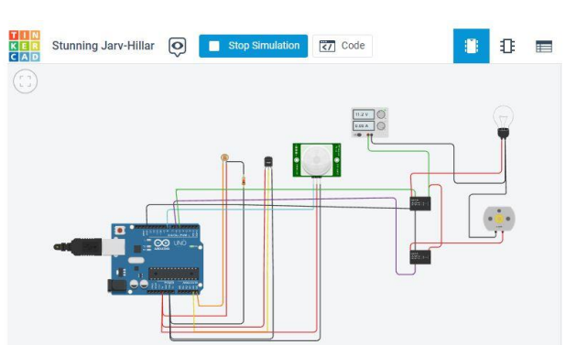 **Circuitcode**

float x,y,z,temp;

void setup()

{

pinMode(8, INPUT); pinMode(5, OUTPUT); pinMode(6, OUTPUT); pinMode(A5, INPUT); pinMode(A4, INPUT); Serial.begin(9600);

}

void loop()

{ x= digitalRead(8); y= analogRead(A5); z= analogRead(A4); Serial.println(x); Serial.println(y); Serial.println(z);

temp = (double)z / 1024;

temp = temp * 5;

temp = temp - 0.5;

temp = temp * 100;

if ( (x>0) )

{

if ((y<550)&&(temp>30)) {

digitalWrite(5, HIGH); digitalWrite(6, HIGH);

}

else if((y<550)&&(temp<30))